Operating manual for
gambling hall control system OBSERVER+

Contents

1. General information about OBSERVER+ system 3
2. Connection of hardware modules 4
2.1. Slot machine controller 4
2.2. Web-camera 5
2.3. Data output device for Jackpot system 5
3. OBSERVER+ software module 6
3.1. Installation of OBSERVER+ module 6
3.2. Setup of OBSERVER+ module 6
3.3. User's manual for OBSERVER+ module 6
4. Video surveillance software module 9
4.1. Installation of video surveillance module 9
4.2. Set up of video surveillance module 9
4.3. User's manual for video surveillance module 9
5. JackPot software module 10
5.1. Installation of JackPot module 10
5.2. User's manual for JackPot module 10

1. General information about Observer+ system
OBSERVER is a completely new effective device for gambling site management in which the latest high-tech achievements in the sphere of electronics and computer technology are integrated. Our experience and knowledge of the gambling industry and the difficulties which the owners and managers of gambling halls and casinos face made it possible for us to us to work up a powerful, reliable and at the same time easy-to-use device which would allow to control, collect the statistics and analyze work of the gambling site.
OBSERVER+ is built up on base of hardware-software module which is compatible with all known gambling machines and electronic roulettes. It does not need any special server equipment or other expensive devices. The functioning of our system is provided by a simple computer operating on Windows XP platform, and a small controller, which is switched directly to the gambling device. The connection between the governing computer, machines and the surveillance cameras is accomplished with the help of wire or wireless net at the speed of 10 Mbit/sec. Any Internet browser, for example, Internet Explorer, could be used as the governing frame. For external system administration on-line or dial-up connection to Internet is required.
OBSERVER+ system includes three basic modules – gambling hall control and statistics module, digital video surveillance module and JACKPOT module, which could be supplied as a complete set or separately. OBSERVER+ is based on application of World Wide Web and LAN technologies and includes built into slot machines controllers, Web-cameras and a computer operating as a server. Connection of controllers and Web-cameras to the server is realized by means of “twisted pair” cabining. A wireless connection of the devices mentioned is also possible by means of Wi-Fi technology. Gambling hall supervision is possible by means of a computer set up in the gambling hall or through Internet from remote computer. High reliability of data security while using Internet is guarantied. Slot machine controlling module registers all monetary incomes and outcomes as well as such procedures as opening of slot machine doors and of service screens. Slot machine controller does not affect functioning of game board and other slot machine devices. On the whole gambling hall remote control system OBSERVER+ is a reliable instrument to prevent cheating on part of both gamblers and the staff of the gambling house.

To operate software modules of OBSERVER+ system it is necessary to have the following programs installed in the computer: MS Windows XP SP2, NET Framework 1.1 sp1, IIS, MS SQL sp4.

2. Connection of hardware modules

2.1. Slot machine controller

Slot machine controller is a device which is connected across to the game board and to the slot machine control and management units (buttons, keys, counters). Slot machine controller is meant for collecting information about credits received by the slot machine and machine occurrences, such as entering statistics screens, cash-in and cash-out credits, opening of the doors and so on.
Controller’s connection to the slot machine is realized through 25pin socket with the help of a cable. Cable wires allocation is noted in table 1. Connection of the cable wires to the slot machine units is done by means of Scotchlok connectors.
Connection of slot machine controllers to the computer is realized though the local net by means of “twisted pair” cable.
Table 1
Cable colour * | Pin | Allocation | Decipherment | Comments
Yellow | 1 | + 12В | Power
Black | 2 | GND | General
Blue | 3 | JackPot Output | Connected to the light alarm managing board,  TTL signal | Connection is possible if JackPot system is installed
Blue | 4 | Input  OUT SW | To the delivery key wire
Green | 5 | Input  COIN A | To the IN-counter wire | Connection to any other pair of mechanical counters displaying cash-in/cash-out credits in the slot machine is also possible
Green | 6 | Input  COIN B | To the OUT-counter wire
Blue | 7 | Input  STAT SW | To the short statistics key wire
Blue | 8 | Input  SERV SW | To the long statistics key wire
White | 9 | Input  START key | To the START button wire | Connection is possible if JackPot system is installed
White | 10 | Input  START lamp | To the START lamp wire | Connection is possible if JackPot system is installed
Red | 11 | Input  FDOOR | To the wire of the front door opening sensor
White | 12 | Input  BDOOR | To the wire of the rear door opening sensor

2.2. Web-camera
Any web-cameras connected to the local net could be used for OBSERVER+system. To set parameters of the camera it is necessary to use standard software, supplied by the cameras. Setting requirements for Web-cameras to work in OBSERVER system:
- Camera’s name and password must be identical for all cameras and must be compliant with the ones used in OBSERVER+ system’s software modules.
- User of the observer camera must be established.
- IP-addresses of the cameras must be assigned successively (for example: camera 1 - 192.168.0.100, camera 2– 192.168.0.101, camera 3 – 192.168.0.102 and so on.
Web-cameras must be hooked to the local net, connected to OBSERVER+ system’s server and provided with power supply in accordance with Web-camera user’s manual.

2.3. Data output device for Jackpot system
Information concerning JackPot system condition and winnings on any of the slot machines could be output to the information board of “creeping line” type and plasma-panel display (both of the variants or just one of them could be used), the winning can also be followed by a sound signal.
Information board is used only in JackPot module. Information boards by different producers could be used. The board can have various dimensions, use different colours and visual effects. Installation and setup of the board must be done by specialists from «Solid Systems» company only in agreement with the customer.
Information board must be connected to the power system of 220 V, 50 Hz and to the governing computer through the com-port.

3. OBSERVER+ Software Module

3.1. Installation of OBSERVER+ module
To install the module you need to start the installation package and follow the instructions!

3.2. Setup of OBSERVER+ module

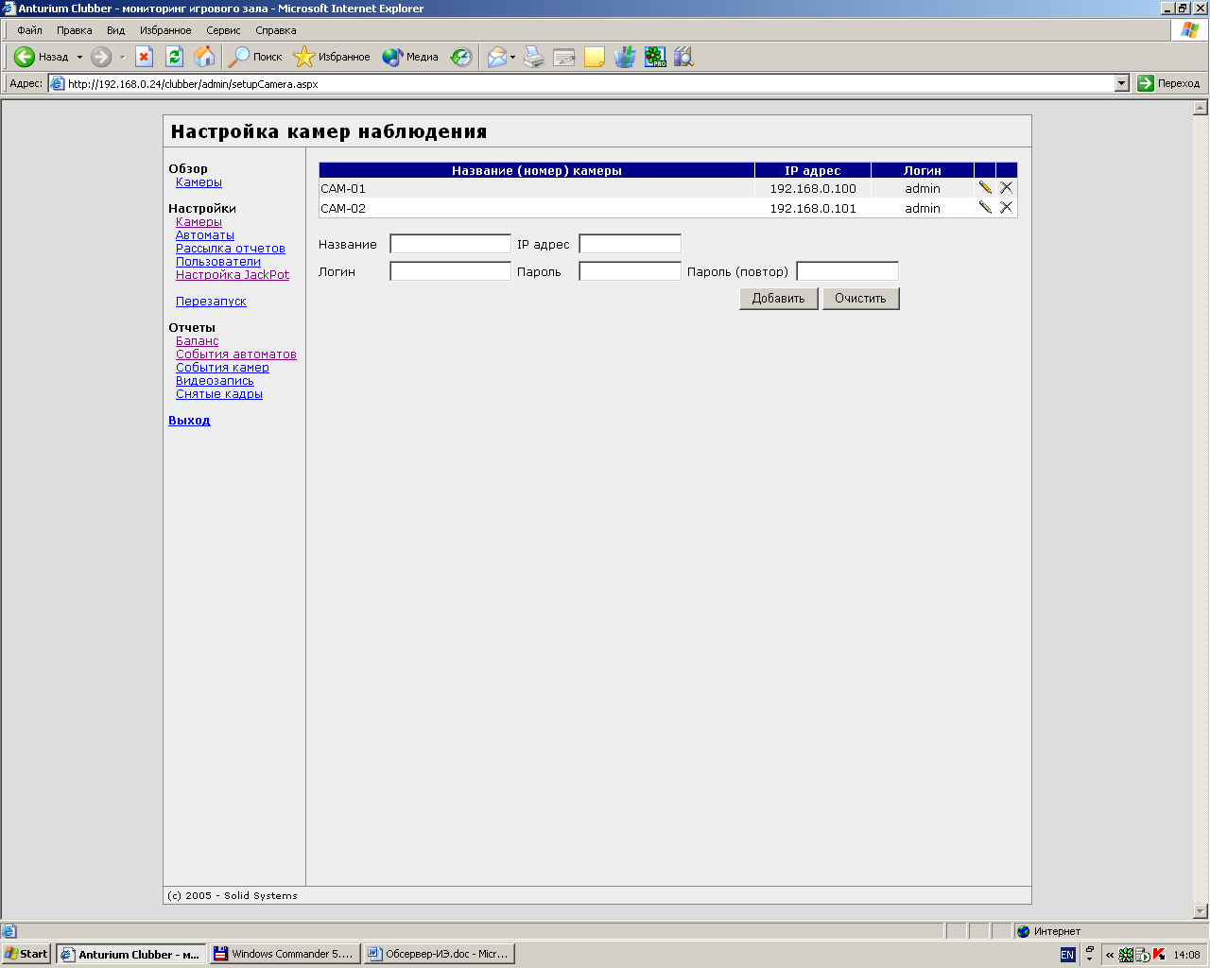
Pict. 1.
OBSERVER+ software module consists of system service and Internet site, witch can be loaded on local or remote computer. System setup is realized on the respective pages of this site.

A) Camera parameters setup is carried out on the page settings\cameras (pict. 1). To connect web-cameras it is necessary to enter camera name, ip-address, login and password and press the button “add”. On this page you can also delete cameras from the list of the connected ones and to change parameters of the cameras.
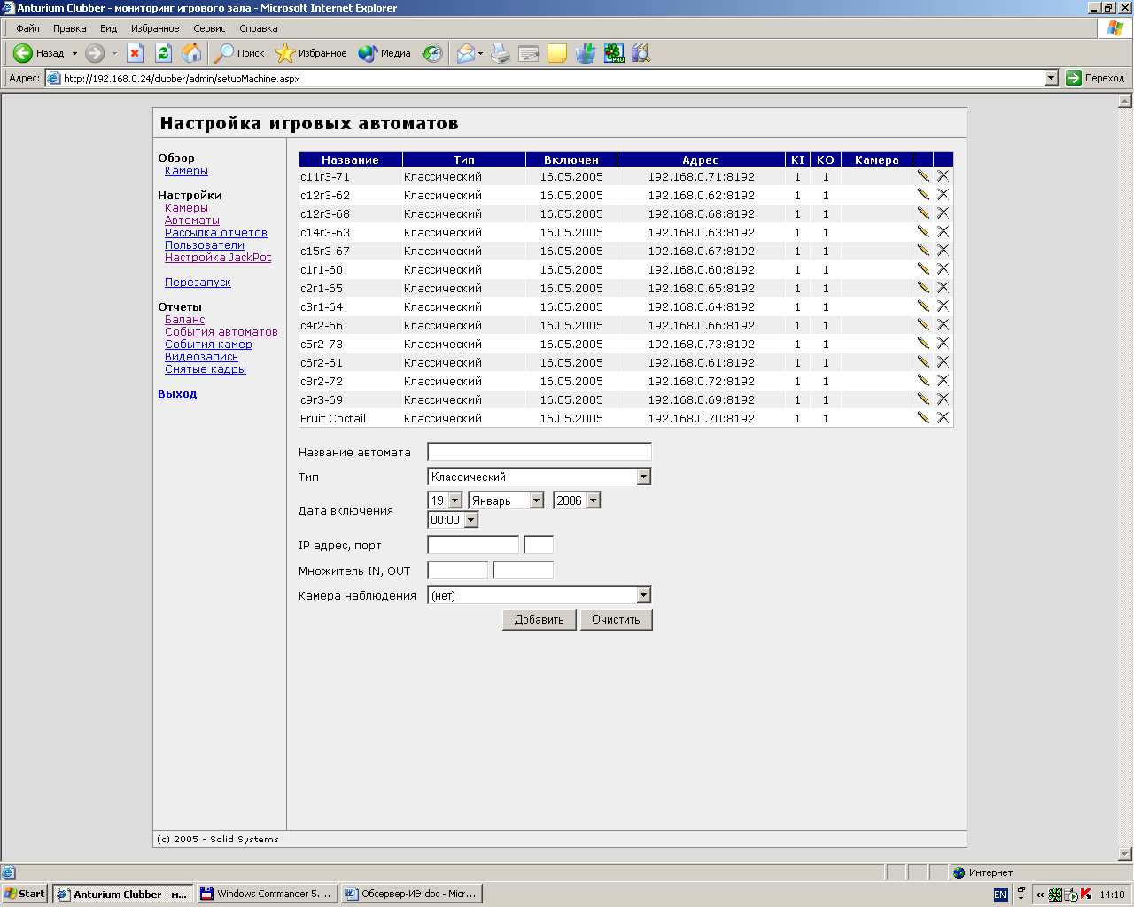
Рис. 2

B) Slot machine parameters setup is carried out on page settings\machines (pict. 2). To connect a slot machine to the OBSERVER+ system it is necessary to assign the following parameters:
- machine name,
- type of the machine,
- date of switching on (the current date is inserted automatically),
- IP-address (type of address: 192.168.0.XXX)
- port (8192)
- in and out multipliers – i.e. cost of one impulse of the counter in roubles or in other currency.
- camera (provided video surveillance is installed and the option of automatic video recording from the chosen camera is available, the camera switches on at certain machine occurrences).
C) Reports setup is carried out on page settings\reports. OBSERVER+ system provides an opportunity to send repots by e-mail. To use the function you need to set the report delivery flag and prescribe the delivery schedule.
D) Subscribers setup is carried out on page settings\subscribers. OBSERVER+ has two groups of subscribers: admin и user. Subscribers of the user-group can only browse the reports; subscribers of the admin-group have access to the setting pages.
E) System service restart is accomplished on choosing the respective option in the menu. Restart must be carried out in case of introducing any alterations into the settings to actuate these alterations.

3.3. User’s manual for OBSERVER+ module

Web-interface of OBSERVER+ software can be loaded both on local and remote computer. The interface contains a number of reports, which allow to supervise the gambling hall functioning. To control functioning of the gambling hall the following reports could be used: Balance, Machine occurrences, Camera occurrences, Video surveillance, Shots taken.
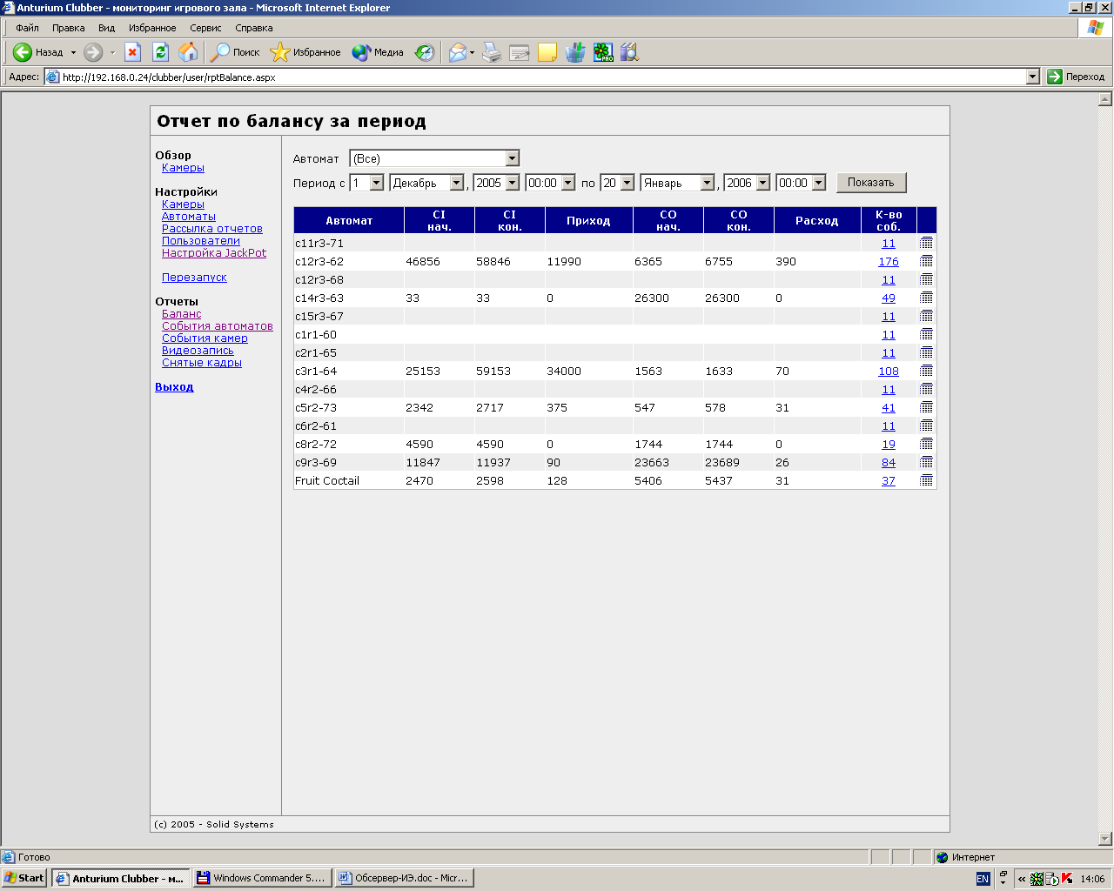
Pict.. 3.

Balance report (pict. 3). Presents data concerning slot machine bash-in and cash-out, all the machines or one particular slot could be chosen (picked by the user by the name). The information is output for the period between the initial and the final date. On default the current date is set as the final date, the day before - as the initial date. The balance is calculated for all the machines. The report is output in the form of a table and contains: initial and final figures of the in-counter, initial and final figures of the out-counter, cash-in, cash-out and number of the machine occurrences.
Report of machine occurrences. Presents data concerning slot machine occurrences, all the machines or one particular slot could be chosen (picked by the user by the name). The information is output for the period between the initial and the final date, picked by the user. On default the current date is set as the final date, the day before - as the initial date. The balance is calculated for all the machines. The report is output in the form of a table and contains: machine name, date of the occurrence record, date of the occurrence registration, name of the occurrence, message. Possible machine occurrences are listed in table 2.

Table 2
Machine occurrences
№ п.п. | Name of the occurrence | Interpretation | Commentary
1 | Controller switch on | Power up of the controller (either with the slot machine, or connection of 25 pin plug)
2 | Loss of the controller connection | Controller switch off from the local net.
3 | Return to the normal mode | Controller starts to work in the mode of collecting information about slot machines operating (after switching off or lost connection)
4 | Entering Short statistics | Turning the key of Short statistics
5 | Entering Long statistics | Turning the key of Long statistics
6 | Counter 1 mode change | Cash-in credit
7 | Counter 2 mode change | Cash-out credit
8 | Active button press |  | Used by JackPot system
9 | Front door opening | Front door opening | If door opening sensor is installed
10 | Rear door opening | Rear door opening | If door opening sensor is installed

Report of camera occurrences. Presents data concerning camera occurrences, all the cameras or one particular camera could be chosen (picked by the user by the name).The information is output for the period between the initial and the final date, picked by the user. On default the current date is set as the final date, the day before - as the initial date. Occurrences of all the cameras are recorded. The report is output in the form of a table and contains: camera name, date and time when frame recording began, date and time of the fault registration, fault description. Information of failed frame recording attempts is also output in this report.
Video surveillance report. Presents data concerning video recording for cameras, all the cameras or one particular camera could be chosen (picked by the user by the name). The information is output for the period between the initial and the final date, picked by the user. On default the current date is set as the final date, the day before - as the initial date. Occurrences of all the cameras are recorded, video records from all the cameras are registered. The report is output in the form of a table and contains: camera name, date and time of recording beginning and ending, machine occurrence which caused the recording.
Report of shots taken. Presents data concerning taken shots for cameras, all the cameras or one particular camera could be chosen (picked by the user by the name). The information is output for the period between the initial and the final date, picked by the user. On default the current date is set as the final date, the day before - as the initial date. Occurrences of all the cameras are recorded, video records from all the cameras are registered. The report is output in the form of a table and contains: camera name, date and time of recording beginning and ending, machine occurrence which caused the recording.

4. Video surveillance software module

4.1. Installation of Video surveillance software module

Video surveillance module is meant for recording shots made by web-cameras. This module could be used either together with the OBSERVER+ system or separately.
Video surveillance module consists of two programs. The first program carries out frame-by-frame recording of information from web-cameras to the hard disk drive of the computer. The second allows browsing shots recorded and choosing the shots necessary for further work. Installation of the first program is realized by starting setup.exe and following further instructions. To set up the browsing program it is enough to record it on the HDD. To start frame recording it is necessary to reload the computer or start NetCamSvc server.

4.2. Installation of Video surveillance software module

Installation of Video surveillance software module is done by the specialists from Solid Systems Company. On request of the customer the following parameters could be set up:
Folder for recording shots from the cameras.
The shot is recorded to the folder:
ROOT FOLDER\YEAR\MONTH\DAY\CAMERA\HOURS-MINUTES
Where ROOT FOLDER is any folder on the hard disc (for example d:\video), YEAR is the current year, for example 2006, MONTH is the number of the month, for example 10, DAY is the day of the month, for example 8, CAMERA is the camera name, for example cam1 (the cameras are named cam1, cam2… in accordance with the ip address, beginning with the minimal), HOURS-MINUTES, for example 18-20.
With the following settings the shots will be recorded to the folder:
D:\video\2005\10\8\cam1\18-20
Storage time of of files on the disc.
In order the hard disc of the camera is not overfilled the shots are stored for some limited period of time, and then deleted when the time limit expires. Storage time limit depends on the image quality settings, hard disc capacity size and the customer’s request. By default storage time comprises 72 hours.
Time interval (in minutes) of new folder creation.
By default folder HOURS-MINUTES is created every 5 minutes. On the client’s request this time period can be altered.

4.3. User’s manual for Video surveillance software module

5. JackPot software module
LackPot software module is designed for drawing of a prize (a sum of money or a thing) among the slots connected to the OBSERVER+ system.

5.1. Installation of JackPot software module
JackPot software module consists of two parts – web-interface and JackpotWin software module. Installation of JackPot software module is carried out with the help of the installation package, setup is carried out according to the instructions.

5.2. User’s manual for JackPot software module
OBSERVER+ system with installed Iackpot module allows Jackpot drawing for any number of slot machines connected to the OBSERVER+ system. The drawing is done for four Jackpot types (percent of cash-in credits, percent of cash-in and cash-out credits difference, a fixed sum, material prize). The system provides 5 variants to determine the winner-slot: at random, or depending on the cash-income and cash-out credits (for further information see below).
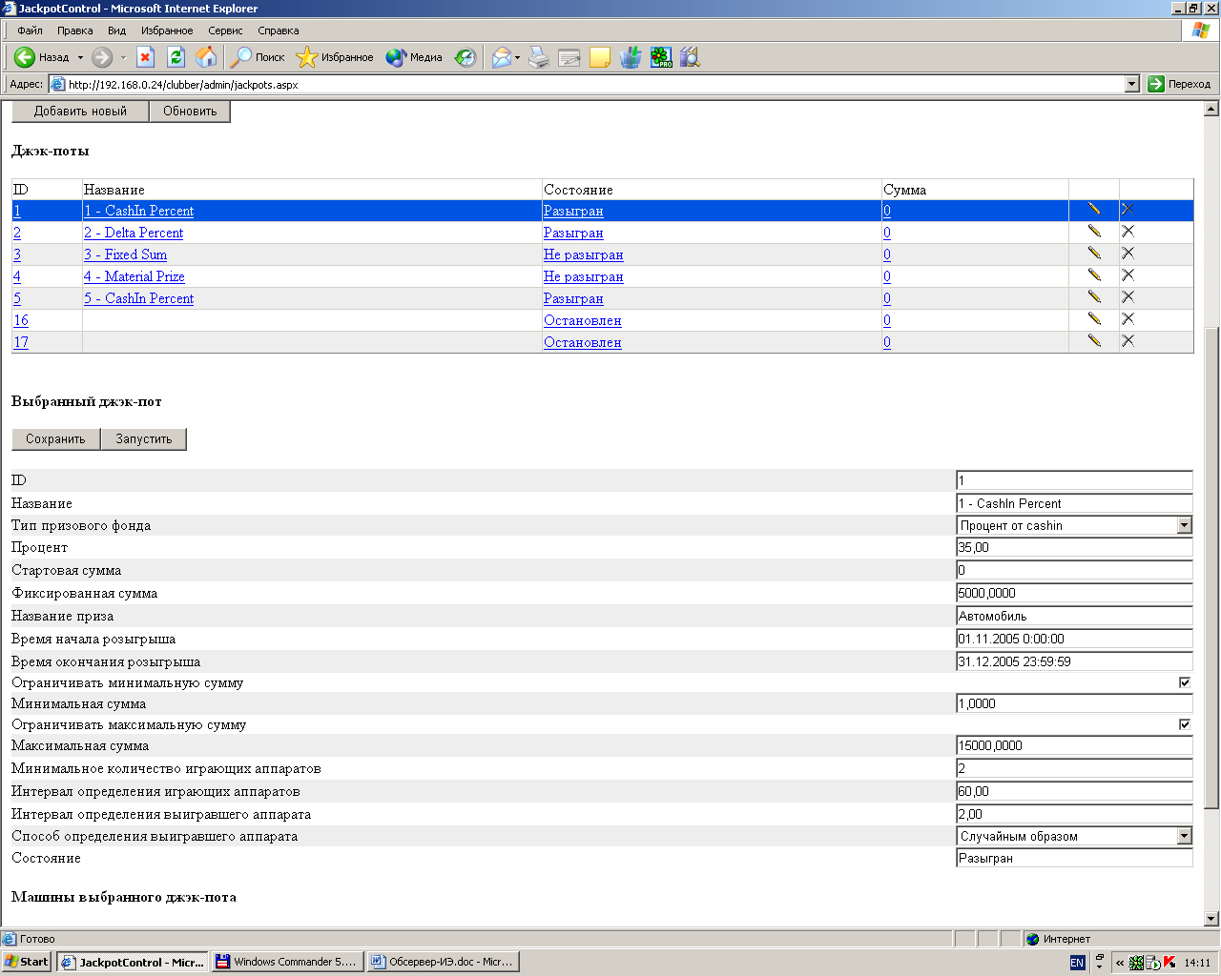
Pict. 4.

JackPot software module consists of two parts – web-interface and JackpotWin software module. Access to JackPot module settings is provided on the settings/jackpot web-interface page (see pict. 4).
ADD NEW button allows to create a new jackpot. UPDATE button allows to update the information about the condition of all the jackpots available. In the table (the top part of the screen) there are listed all the existing jackpots, their names, the current state and the sum raffled off. SAVE BUTTON ALLOWS to save all the alterations in the settings of the jackpot chosen. START button starts the chosen jackpot. Jackpot module has the following settings:
- ID – identification number, assigned automatically when a new jackpot is created.
- Name (on picture 1 – Cash In Percent) – any name insert by the user.
- Jackpot type – an opportunity to choose one of the four types:
1 – Percent of cash-in – percent of the credits received by the slot (the percent is set by the Percent setting).
2 – Cash-in – cash-out percent – percent of the difference between the cash-in and cash-out credits (the percent is set by the Percent setting).
3 – Fixed sum – allows prescribing of a fixed sum for drawing, which is set by the Fixed Sum setting.
4 – Material prize – allows prescribing of any non-monetary prize for drawing, the name of the prize is chosen by Prize Name setting.
- Percent – percent of cash-in credits or of cash-in and cash-out difference, depending on the Jackpot type.
- Initial sum – for the first two Jackpot types, with the help of this setting an initial sum which does not depend on the cash-in credits could be prescribed.
- Fixed sum – is a setting for the Fixed Sum Jackpot type.
- Prize name – is a setting for Material Prize Jackpot type.
- Draw beginning time – the date and time when the drawing begins is set.
- Draw ending time – the date and time when the drawing begins is set.
- To limit the minimal sum – if the flag is set, the drawing falls to a slot machine only when the drawn sum exceeds the minimal sum preset by the Minimal Sum setting.
- Minimal Sum – a setting for Jackpots of the 1 or 2 type. If the flag of minimal sum limit is not set, the setting is neglected.
- To limit the maximum sum – if the flag is set, the drawing cannot exceed the sum, set by the Maximum Sum setting.
- Maximum Sum – a setting for Jackpots of the 1 or 2 type. If the flag of maximum sum limit is not set, the setting is neglected.
- Minimal number of the slot machines engaged – if the number of the machines engaged at the moment is less than indicated by the setting, the Jackpot is not drawn.
- How to determine the winner-slot. Jackpot system allows to choose one of 5 methods to determine the winner-slot:
1 – At random. The winning falls to a randomly chosen slot which participates in the drawing and is active at the moment.
2 – Maximum cash-in. The winning falls to the slot that has received the maximum number of credits for the drawing period.
3 – Minimal cash-in. The winning falls to the slot that has received the minimal number of credits for the drawing period. This type of drawing is recommended to attract the gamblers’ attention to a particular slot-machine.
4 – Maximum cash-in – cash-out difference. The winning falls to the slot that has received the minimal number of credits for the drawing period. This type of drawing is recommended to attract the gamblers’ attention to a particular slot.
5 – Minimal cash-in – cash-out difference.
- Chosen Jackpot machines – the setting allows to choose all or part of slot machines to participate in Jackpot drawing.

